**Age Concern Eastwood**

**Dementia Project**

***Working in Partnership with East Renfrewshire Council***

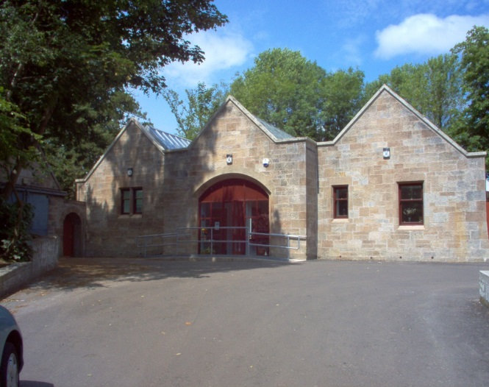

**The Stables**

***Services awarded top marks, “Six-Excellent,” in all categories***

***by Care Inspectorate. Copy of report can be obtained from the Office.***

***Service Handbook***

**Tel: 0141 621 0133**

**E-mail:** [**eastwooddementia@btinternet.com**](mailto:eastwooddementia@btinternet.com)

**Website:** [**www.ageconcerneastwood.com**](http://www.ageconcerneastwood.com)

**Registered Charity No SCO 22539**

**Non-Profit Company Ltd by Guarantee No 181705**

**Registered with OSCR (Office of the Scottish Charity Regulator)**

**Registered with Care Inspectorate**

**Service Provider no: SP2003000156**

**& Care Service no: CS2003000802**

**The Centre follows and adheres fully to the standards set in the National Care Standards and the SSSC Codes of Practice 2016.**

**WELCOME TO THE CENTRE**

***Age Concern Eastwood Dementia Project***

***Mission Statement***

***Our main objective is to provide a high quality day care service in order to promote the health and wellbeing of our clients and carers. The mission of the Centre is to follow a holistic approach to dementia care. We believe that the carer equally requires as much support and care as the person for whom they care.***

***Definition of Dementia***

Dementia is an umbrella term for a range of signs and symptoms which indicate that there may be changes occurring in the brain. Gradually the person who has dementia loses the ability to do certain tasks. Memory is often the first thing to be affected. The person may become confused about who people are, or what time and day it is. The person’s personality may change. As the illness progresses the person will require more help to do simple tasks like dressing, eating and using the toilet.

The most common type of dementia is Alzheimer’s disease. Other types of dementia include: vascular dementia, alcohol related dementia, Lewy Body dementia and Pick’s disease. Although people with dementia retain positive personality traits and personal attributes, as their condition progresses they may experience some or all of the following: memory loss, language impairment, disorientation, changes in personality and difficulties with activities of daily living, self-neglect, psychiatric symptoms and out-of-character behaviours’.

***NUMBER OF PEOPLE AFFECTED BY DEMENTIA***

***There are over 1,838 diagnosed cases of dementia in East Renfrewshire***

***& over 93,282 across Scotland.***

Dementia is a set of symptoms: “evidence of a decline in memory and thinking which is of a degree sufficient to impair functioning in daily living, and is present for six months or more”. This may be accompanied by a decline in emotional control, social behaviour, motivation and chronic personality changes*.* The list of problems associated with dementia, over and above those generally considered common to old age; bring a level of vulnerability and isolation as the illness progresses. This must be continually assessed and addressed to avoid crisis situations. Dementia is not only a psychiatric illness but rather a term used for signs and symptoms with widespread physical and social manifestations. People with dementia require particular attention while they remain living within their communities to ensure their safety and wellbeing. Support should also be offered to their carers’ in this very demanding role.

The Centre has an open referral system allowing everyone who has a diagnosis of dementia and lives within the East Renfrewshire Authority to access our day care services and our carers’ services. Be reassured that all enquiries or referrals to the Centre are treated in the strictest confidence and our staff adheres fully to the *Data Protection Act 1998, The GDPR regulations and we are ICO registered*.

***Our Commitment to Care***

Recognising that people with dementia have many complex needs including physical, psychological, emotional and social is simply not enough. The description “day care” has in the past raised many mixed views as it generally implies a stereotypical image of people with disabilities who are solely dependent on others in an institutional building.

Our day services (commonly known as “The Club”) differs considerably from the stereotypical image and our premises were specifically designed in partnership with Carers, Clients, staff and East Renfrewshire Councils architects to provide the highest standards of care and respect to people with dementia.

*C:\Program Files (x86)\Microsoft Office\MEDIA\CAGCAT10\j0291984.wmf“People with dementia often experience memory loss to varying degrees; they can be easily disoriented and confused and their behaviour can vary considerably with boredom, depression, fear and anxiety. In addition, they can be aggressive, uninhibited and restless for reasons not fully understood or frequently prone to wandering. The alleviation of these characteristics and regressive behaviour traits can be addressed within the physical environment by careful design and scale”.*

*(Cohen and Weisman: Maryland, USA)*

***Facilities at the Centre***

We have two day care facilities, one large and one smaller, which comfortably accommodate 26 people per day. Both are domestic in scale and as the premises have been equipped to address clients’ needs safely and comfortably, even the more physically frail can be accommodated. The centre is opened from 9.00am -4.30pm.

Carers can be assured that anyone attending our centre is treated with dignity, discretion and respect at all times.

The Centre provides continuity of care for individuals as we employ a highly trained permanent staff team, who will get to know the needs, likes and dislikes of all who attend. Therefore no one is reliant on an individual member of staff as this can prove problematic when they are on holidays or off sick. Our centre has a robust recruitment and selection policy that has been devised to incorporate all the legal requirements outlined in the Safer Recruitment through Better Recruitment guidance, (Care Inspectorate & SSSC Nov 2016).and the SSSC codes of practice, Nov 2016 as well as the new Health and Social Care Standards Apr 2018.

Ongoing development through training is placed at the top of the agenda to secure effective delivery of a high standard of care services that comply fully with Centre philosophy and The Protection of Vulnerable Groups (Scotland) Bill, which was introduced in September 2006. Our emphasis is to attract the most suitable candidates who can become productive members of our staff and are safe to work with our vulnerable clients.

All staff must hold an enhanced disclosure from CRBS (the disclosure scheme is provided for in Part V of the Police 1997 Act) before they can work or volunteer in our Centre.

It is also not unusual for people to believe that “day services” are only to give respite to the carers. As much as respite **is** **essential** to carers by providing them with some rest or to address their own needs as well as, for some, to continue working while knowing the client is being well supported, our day care provision is nevertheless for the direct benefit of the person with dementia.

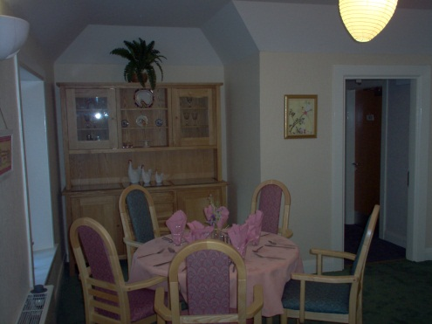 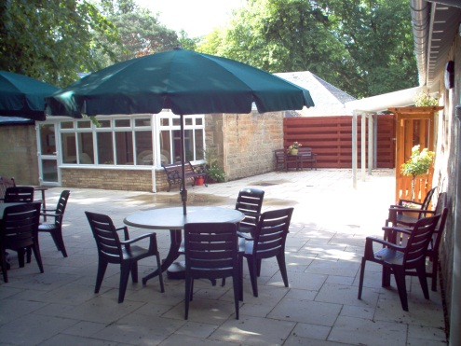

Smaller day care dining room Patio area between both day cares

In order to ensure that people gain full advantage of their time at the Centre we have

**No** **televisions.** Instead there is a programme of purposeful and meaningful activities for clients to enjoy and where interaction with others is a priority.

***Personalised Care Package*s**

Everyone who attends the day service is allocated a named Key Worker who will compile and assess their care plan (CP1) to ensure this is kept up-to-date. They will also link with other agencies to ensure a coordinated package of care.

The Key Worker is also the point of contact for Carer and staff from other agencies who may have concerns for the client and they can also advise the Carer of services available for them. This arrangement is very successful at highlighting potential problems that require further monitoring or urgent review before the problem becomes a crisis, i.e. illness, physical and mental decline, personal care issues, etc. Where possible, issues will be addressed directly at the Centre.

**Daily charge of £10**

When a place has been allocated (normally one day per week) this must be booked and paid for four weeks in advance. Where a bus place is required a £6.00 daily charge for this service will apply. If, for whatever reason, the reserved places are not required we will endeavor to fill them but we cannot guarantee this and the charge may still apply. The account will be forwarded to you directly by email or post, please state your preference to staff.

**Important Information Regarding Client Medication**

As the Centre is not a medical facility, we do not consider the administration of medication as a normal responsibility for our staff. We recognise, however, that it may be essential for some drugs to be given during the time that we support a person at the Centre. Therefore, we will, on the carer’s instruction and responsibility, prompt/assist clients to take (oral) drugs that have been prescribed by a doctor.

**Only the amount to be taken at day care should be sent. The drugs should be clearly marked, in a secure container, with the person’s name, time to be administered and the name of the drug.**

**The Centre office must be notified of any changes to a person’s medication in order that the medication records can be amended accordingly.**

**Transport**

Please note that there are limited places available on the bus hired by the centre and a time restriction applies. Therefore places cannot be guaranteed. Many, client/carers do however prefer to make their own arrangements for transport as pick up times by the bus can vary considerably.

***Personal care at the Centre***

Showering: Many of our clients require assistance with showering by fully trained and professional staff. Clients fully engage in the process by choosing the products they prefer to use, i.e. shower gels, shampoos, etc.

Please note for clients who require incontinence products, a supply should be left at the Centre for changing.

Carer’s Please Note: If, for whatever reason, a client refuses to have a shower regardless of how much the service may be required, we cannot force clients against their will.

Laundry: When showers are pre-arranged, the client will be asked to bring a fresh change of clothing which will be laundered and returned. A change of clothing for those requiring showering services at each visit will be kept at the Centre.

**(There are no additional charges for this service however clothes are laundered as a courtesy therefore if professional cleaning is required this must be externally sought).**

Hairdressing: Clients having their hair washed are asked how they would like it styled, i.e. blow dried, tonged, curlers, etc. Every effort is made to ensure the client’s preferred style is maintained. **(There is no charge)**

Our staff is not trained hairdressers therefore a local hairdresser Leslie calls for hair cutting, etc. on a Tuesday, Thursday or Friday.

**(Charges are £11-£22 for women & £7 for men paid directly to the hairdresser or added to the clients account).**

Manicure/ Hand Massage: Clients are offered a relaxing hand massage followed by nail cleaning, filing and their choice of polish.

Clients refer to this as “pamper sessions” and they find this a very pleasant experience, over and above the basic hygiene perspective. **(There is no charge)**

Podiatry:A professional Podiatrist, Kate France Bsc (Hons), visits the Centre if/when required. All general foot care undertaken including diabetic and rheumatoid conditions; nail cutting, callus and corn removal.

**(Charges of £20-25 for treatments payable directly to Kate or alternatively it can be added to monthly account).**

***Dining Experience***

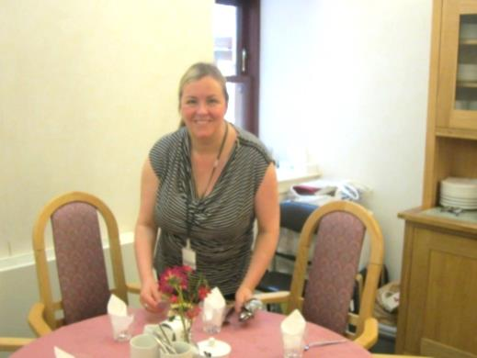Every meal is a special occasion and as such they are served on freshly laundered tablecloths and dressed attractively with flowers and glasses.

Nutrition:Many of our clients live alone and we are aware that their diet may be lacking in essential nutrients, adequate fluid intake and variety. We seek to address this when the person attends the Centre by ensuring the food contains their “five a day” requirement of fruit and vegetables.

Fluids levels are monitored throughout the day by our professional staff team to prevent dehydration. This is essential as inadequate fluid intake can lead to painful UTI’s and unnecessary hospital admissions.

We cater for clients who have special diets, diabetic needs, food allergies or intolerances. We also provide particular requirements, i.e. plate guards, adapted cutlery, soft options or assistance to eat.

Food selection: From 9am onwards the clients’ day starts with a selection of breakfast choices being offered on arrival. This consists of tea/coffee, cereal, porridge, toast with bananas, sugar free jam/marmalade or cheese, etc.

At approximately 11.45am clients are offered freshly prepared fruit or a fruit smoothie.

Lunch generally begins around 1-1.15pm and consists of three courses: soup, main course and dessert.

Clients are encouraged to choose the type of meal they prefer and this is served with water, juice or milk. Thereafter tea/coffee and biscuits are served.

Regardless of how slowly clients like to eat they are never hurried and the atmosphere is relaxed to ensure they enjoy their lunch. (All staff holds a food hygiene certificate and Debbie holds a certificate in Nutrition and Malnutrition in older people).

Monitoring Weight: We know that clients are not always aware of the potential dangers to their health and wellbeing of a poor diet, lack of fluids, not eating enough, overeating, etc.

A record of clients’ weight is kept in the file and updated monthly. This record can be an indicator of an underlying problem. Clients, not eating or drinking sufficient amounts to maintain good health or if their weight is falling/gaining steadily, the carers will be notified and a review will be called.

**Stimulation/Activities**

Clients choose from a large selection of activities while at the centre.

Everyone is given a choice of their preferred pastime, but no one is forced to take part against their will. Staff also assesses client requests and source new material for their enjoyment. Day care Volunteers also take part in activities.

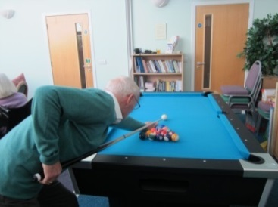

Outdoor Areas: Clients may also assist staff with light gardening, weather permitting. If they wish they can enjoy a game of bowls, croquet, snooker, darts, dancing, and group ball games on the clients’ patio area as well as accessing the many indoor facilities.

Physical frailty: All activities can be enjoyed by our frail and wheelchair clients in a safe and secure environment therefore no one need be left out.

Participation helps to improve circulation and exercise has been proven to help reduce falls. It will also increase a person’s sense of achievement from being part of a group. We aim to address the social isolation experienced by many people therefore we encourage all who attend to vary their interests and level of interaction with others throughout the day.

Musical Memories Group: Singing is an activity that is proven to benefit all people cognitively and generally to lift their mood and attitude. As well as the daily (unprompted) sing-songs we hold concerts at the Centre where clients’ take part with a professional performer and staff. We also have a supply of musical instruments, guitar, piano/organ for clients to play and enjoy.



Physical Exercise: Dancing, of course, improves circulation as well as helping to relieve stress.

We always encourage clients to be as independent as possible and regardless of frailty they will be supported to be as pro-active as they can.

Many of our clients are more comfortable with chair exercises and games specifically designed to increase circulation. For the more physically capable they can take part in more demanding exercises.



Arts & Craft:Not all exercise has to be physical to be beneficial. Clients enjoy the knitting bee, painting, drawing, card making, etc. Also there is always the favorite pastimes reminiscing and chatting with your peers.

**Personal Belongings**

We appreciate that some personal items are extremely important to our clients e.g. money, jewellery, photographs etc. We ask that **only** articles essential to the person be brought to the Centre. We hold all relevant insurances i.e. Public Liability, Professional Indemnity, Employer’s Liability, Building Insurance and Building Contents Insurance. All certificates can be found in our office premises. However, when at the Centre if an article is reported lost or stolen the responsibility is on the Carer or client to prove to the Insurers that the article was in fact lost or stolen whilst here.

***Discharge from Day Care***

On notification of **hospitalisation,** the reason for illness will be recorded in the client file and the Key Worker will contact the named carer for updates. After a four week period, if no return date has been suggested the person’s permanent place will be allocated to another client. Until further notice the client’s file will be held on record pending a conclusion regarding the person’s long term care. If the client wishes to return to the Centre after an extended period in hospital they will be allocated a stand-by place until a permanent place becomes available.

When a client **moves out** of East Renfrewshire the Centre will be unable to continue to offer day care services. However, we will assist in finding an alternative in the area where you will be living. Likewise when client has a place in permanent care in a care home our services must be withdrawn.

If a client displays **unexplained** **behaviours that challenge** and put other clients and staff at risk, the carer would be asked to attend a review at a venue of their choice. Explanations would be sought to identify the source of the behaviour problems e.g. change of medication, inappropriate medication, change in living/family circumstances, etc. The outcome of the review will determine whether the person can return to the Centre safely.

***Sharing Information***

In emergency situations, e.g. hospital admissions/respite care/police searches, we will provide other agencies with a copy of the front cover of clients’ files.

This document contains important information that could be crucial to the person’s wellbeing, i.e. medication, photograph, next of kin, weight, height, DOB, address, Social Worker, CPN, Doctor, etc.

Carers may request a copy of the front cover as well as the clients CP1 (Care Plan 1) to use when they are on holiday in the event that the person they care for wanders off or requires hospital treatment. Carers may also use these documents as a point of reference for other respite facilities allowing them an up-to-date insight of the person’s needs and preferences rather than having the Carer repeat the same information every time.

***Students***

The Centre welcomes students from different disciplines throughout the year. All students are mentored by a member of staff who discusses any questions they have before or after the clients have gone home. This ensures that the learning is unobtrusive and minimizes any disruption to the clients’ day.

* The health and social work students spend one day to one week at the Centre.
* The school students spend an hour a week in day care.
* Langside/Cardonald College students working towards their HNC in social care and Strathclyde/Caledonian University students studying social care spend a day a week.

The Centre is pro-active at all times in ensuring that we contribute positively to raising the standards in care for our very vulnerable clients. By co-operatively working with other agencies, we not only promote good standards but use these opportunities to increase our knowledge of health and social care needs.

***Smoking Policy***

Our facilities operate a no smoking policy, (copy can be obtained from the office). However clients who do smoke are allocated a designated area that is separate from other clients.

***Services we cannot provide***

Our services are located within our Centre and we are unable to escort clients for shopping, banking, etc. We do, however, appreciate how important these tasks are and we will seek to identify and arrange on your behalf an appropriate agency that can provide these services for you.

***Carers Services***

Fiona Thomson- Registered Manager

Fiona is the carer’s direct contact for advice, information and support. Please contact Fiona if there are any issues that can assist you in your caring role.

At the point of referral, the carers are automatically placed on our Carers List and notified by monthly newsletter of Centre services for them, any forthcoming events, coffee mornings, carers’ education sessions, etc. If you do not wish to be notified, please contact the office to have your name removed from the list. Carers’ details will be removed from the list if Day Care attendance ceases unless otherwise requested.

Carers Coffee Mornings: Coffee mornings take place at 10.30 a.m. on the first Thursday of every month. These are open to family and friends as well as the general public. Staff is on hand to offer advice and support if needed.

Carers Lunches: We aim to hold two lunches each year, one is in June and the other at Christmas. These events are always popular with our carers, who enjoy meeting other carers in a social and relaxed environment.

Carers Information Sessions: There are information days throughout the year and carers will be notified in our monthly newsletter. Requests for specific topics are always welcomed.

Carers Evening Meetings:Meetings will be arranged, at carers requests throughout the year for carers who are unable to attend day events due to other commitments or they find this timing more convenient.

Carers Information: Carers can access information leaflets at the Centre and if we do not have the information you require we will order this for you. Carers are welcome to drop in at any time if they feel they need to talk or can make an appointment for a particular time that suits best either at the Centre or in your own home.

***Assessment of Clients and Carers Views***

We strive to ensure that client’ views, opinions and suggestions dictate the services offered. We do this by:

* Clients are asked for ongoing feedback when they attend the Centre if they are receiving the services they require and for suggestions of how the services can be improved.
* Carers are asked when attending events at the Centre or at reviews and are asked to complete a questionnaire which covers all aspects of our service provision.
* Carers may e-mail us at any time.
* Health and Social Work staff is asked for feedback on how the Centre services integrate with their clients’ needs and how they think we could improve.
* We inform carers of our annual meeting where they may contribute to the Centre self-evaluation which be completed prior to our inspection by Care Inspectorate.

***Emergency Closure***

Unfortunately we cannot guarantee that certain conditions may not affect our day care services:

* + No heating throughout the premises/No electricity
  + No Water/Flooding
  + Heavy snow/ice that makes escorting clients from their homes dangerous for clients and staff.
  + Flu/virus outbreak affecting safe staff numbers
  + Fire in premises, etc.

If the Centre requires to be closed the following procedure is followed:

All carers will be contacted by telephone. If the Carer is not available or the client has no named Carer, Social Workers or home care will be notified.

***Fire Procedures***

All staff is fully trained in fire evacuation procedures and all clients attending day care have their individual needs risk assessed. All special requirements are listed in the client’s care plan.

***Complaints Procedure***

If, for any reason, you are dissatisfied with the service provided by our Centre, please make an appointment or alternatively drop-in to meet with the Registered Manager to discuss your concerns. A meeting can be arranged to take place in your home if this is more convenient. All complaints will be addressed within seven working days.

The Board of Directors will be advised of the concern and the outcome.

You may however prefer to directly contact:

**The Care Inspectorate**

**Compass House**

**11 Riverside Drive**

**Dundee**

**DD1 4NY**

**Telephone Enquiries: 0345 600 9527**

**Website: www.careinspectorate.com**

Their staff will be happy to act on your behalf.

The Care Inspectorate hopes to resolve complaints within 14 working days. However, more complex complaints may take up to 28 working days.

***Care Inspectorate Report***

*A copy of our latest Care Inspectorate report can be found on their website:*

**Website:** [**www.careinspectorate.com**](http://www.careinspectorate.com)

***Other Agencies Who Can Help***

Community Care Assessment:We would strongly advise all carers to have a care assessment for the person with dementia. This assessment can be carried out by a Social Worker or CPN who is aware of the local services that can best address the special needs of those with dementia. They can also advise you about respite entitlement and they can arrange this respite on your behalf.

As a Carer you are also entitled to a **Carer’s Assessment** to establish your needs. If you would like further information about your rights to service please ask at the Centre office.

MC900446070[1]Community Psychiatric Nurse (CPN): C.P.N.’s are trained nurses and give practical help and advice on mental health issues. They can also advise you on challenging behaviour, sleep disturbances, etc.

MC900217178[1]

Occupational therapist (OT): O.T.’s, help people to remain or to become independent. They assess people’s needs, give advice and can assist in making lifestyle adaptions or changes.

Health Care assistant (HCA): H.C.A.’s participate in social and recreational activities with clients. They play an important part in the long term care of clients with dementia.

***Opticians/Dentists/Doctors***

Many people with dementia can become very anxious in waiting rooms and this can cause upset to the carers and other people attending surgeries. If this is the case, we can arrange with the relevant professionals to examine the client at the Centre where a member of staff will accompany them. As the client will be familiar with the Centre and staff they tend to feel less threatened in these surroundings.

***Lunch/social Clubs***

***Age Concern Eastwood***

MC900060297[1]

Age Concern Eastwood’s office is based here at the Centre. All their work and lunch clubs are solely organised and manned by volunteers who live in this area. If you are interested in attending or to volunteer, please contact their office on;

**0141 638 2158**

Age Concern Eastwood (A.C.E.) has an impressive record of voluntary services to the elderly that span over four decades through their hard work and dedication.

Services they provide:

* Social/Lunch clubs throughout Eastwood serving approximately 100+ people.
* Advice and information shop. (Their office is Based at the Dementia Centre)
* Bus services for the elderly of this community and other voluntary groups six days per week.
* Befriending services, etc.

**Age Concern Eastwood Dementia Project *Quality Assurance***

The Centre strives to ensure the best possible care for its Clients, Carers, Staff, Volunteers and Visitors, by continually assessing and updating all Health and Safety regulations and literature.

A copy of the Centre’s Health and Safety Policy Statement and East Renfrewshire’s Corporate Health and Safety Policy are available from the Centre office, together with all Centre Policy Documents and Procedures.

The Centre is inspected by an inspector appointed by the Care Inspectorate who ensures that the Centre complies with the National Standards, SSSC Codes of Practice, ‘Regulation of Care’ (Scotland Act 2001) and the Carers (Recognition and Services Act 1995), and Vulnerable Adult Groups Act 2006. A copy of our inspection report can be obtained from our office or viewed on the Care Inspectorate website.

**www.careinspectorate.com**

The Centre’s financial standards are reconciled monthly by the Registered Manager and the treasurer, audited on a quarterly basis by East Renfrewshire Council, Annually by Independent Audit, OSCR and by Companies House.

The Centre’s premises and equipment are inspected annually by a Health and Safety Officer and an Environmental Health Officer appointed by East Renfrewshire Council.

Weekly fire safety checks are carried out by the Staff.

The Centre’s fire safety equipment is inspected and tested weekly by members of the Centre staff and annually by Chubb.

The Centre’s water supply is tested for all water borne contaminants quarterly.

All Centre electrical equipment is tested annually by East Renfrewshire Council.

**General Data Protection Regulations (GDPR)**

**Following the new GDPR legislation introduced in May 2018 a copy of our policy can be obtained from our office.**